Name:
Pre Test – C instruments (Teacher Copy)
- How many flats are in the key of Eb? (6.5.3)
  - 1 c. 3
  - 2 d. 4

B-flat, E-flat, A-flat
- Name the flats in the key of Eb. (6.5.3)

- Draw in the key signature for the key of Bb. Be sure to draw in the appropriate clef. (6.5.3)
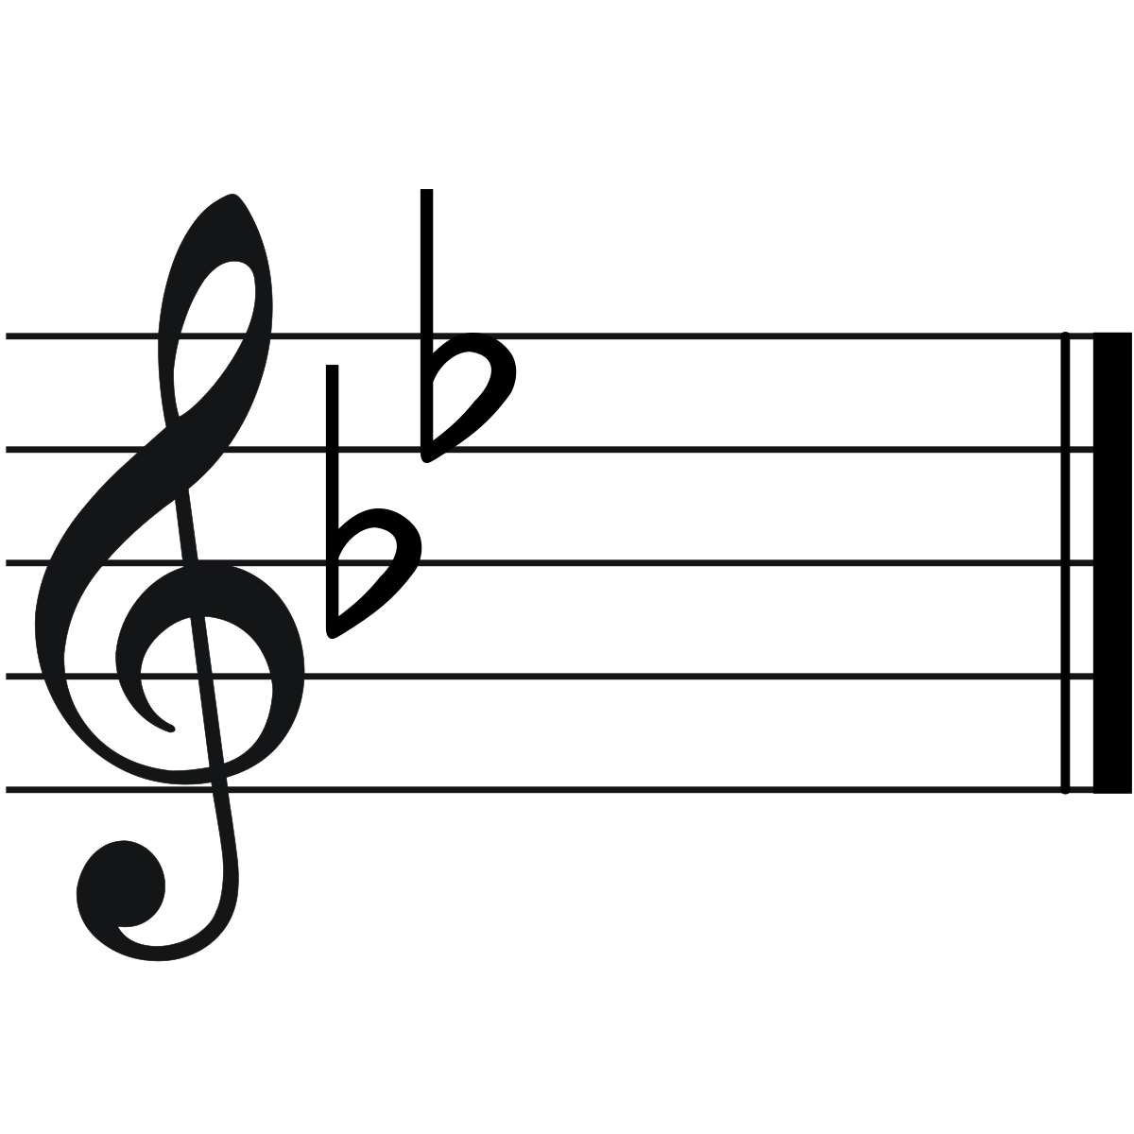
- Describe how you arrived at the answer in question 3. Describe at least 1 piece of evidence/strategy you used to find the answer. Use complete sentences in your response. (6.W.3.1)
(not limited to) I looked at the order of flats. I found B-flat and went one past that, E
Flat. I drew in all of the flats in order through E-flat

- How many flats are in the key of Ab? (6.5.3)
  - 2 c. 4
  - 3
- Draw in the key signature for the key of Ab. Be sure to draw in the appropriate clef. (6.5.3)
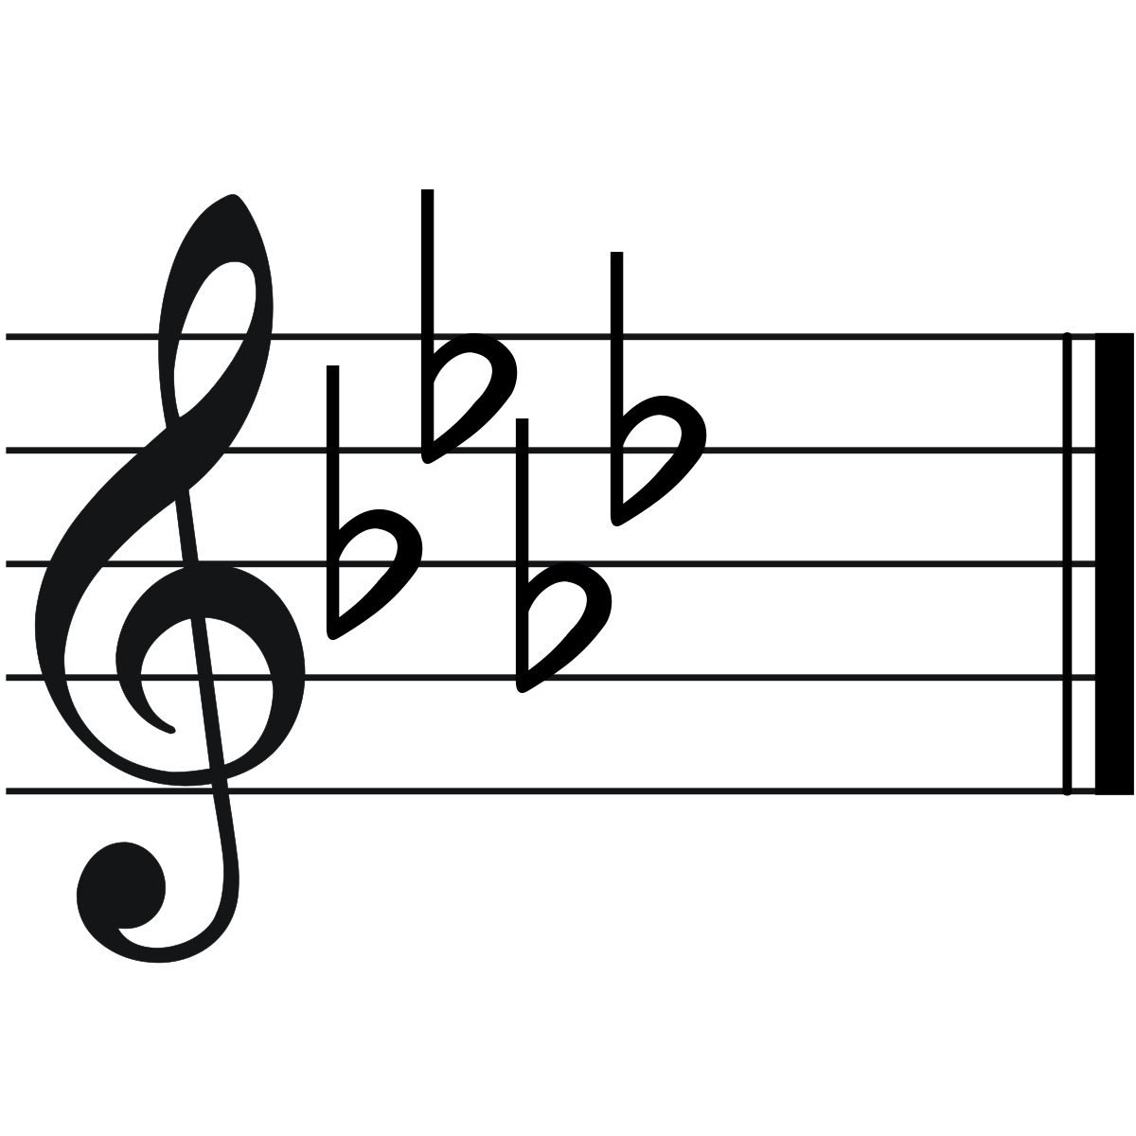
- Describe 3 characteristics of scales. Use complete sentences in your response. (6.W.3.1)
Scales go up, down or both.
Scales go up by consecutive notes.
Scales include all the notes in a given key signature
(Not limited to these responses)

BEADGCF
- What is the order of flats? (6.5.3)
  - Describe how this information is useful for constructing key signatures. Use complete sentences in your response. Your response should be at least 3 sentences long (6.W.3.1)

The order of flats is useful in constructing key signatures by helping us understand which sharps or flats to include. If the key signature uses flats, I know to through the order of flats till one past the key signature I’m looking and that include all the flats I need. For key signatures with sharps, I would reverse the order of flats and then go through them until I find the note one step below the key I’m constructing and I would include all the sharps up to that point

 | 1 point | 2 points | 3 points | 4 points | 5 points
F Major | Did not play scale/ Numerous mistakes, doesn’t self-correct | 5+ incorrect fingerings, struggles with self-correcting | 3-4 Incorrect fingerings, able to fix mistakes | Fewer than 2 incorrect fingerings, quickly self-corrects mistakes | Plays every note with clear, accurate fingerings
Eb Major | Did not play scale/ Numerous mistakes, doesn’t self-correct | 5+ incorrect fingerings, struggles with self-correcting | 3-4 Incorrect fingerings, able to fix mistakes | Fewer than 2 incorrect fingerings, quickly self-corrects mistakes | Plays every note with clear, accurate fingerings
Ab Major | Did not play scale/ Numerous mistakes, doesn’t self-correct | 5+ incorrect fingerings, struggles with self-correcting | 3-4 Incorrect fingerings, able to fix mistakes | Fewer than 2 incorrect fingerings, quickly self-corrects mistakes | Plays every note with clear, accurate fingerings

 | 1 Point | 2 Points | 3 Points | 4 Points
Content | Response does not clearly or accurately answer the prompt. | Response answers the prompt somewhat clearly with major inaccuracy | Response answers the prompt somewhat clearly with minor inaccuracy | Response answers prompt clearly, completely, and accurately
Grammar | Major issues with spelling/grammar, response is difficult to decifer | Minor issues with grammar/spelling, terms may be used with some inaccuracy | Sentences are complete and terms are used correctly, Grammar is correct
Length (when applicable) | Response does not meet length requirements | Response meets length requirement |  | Total points possible = 9

